**PROJECT DOCUMENT**

**For**

**Car Sales Management System**

**Prepared By:**

**Aslan Shaikh, Abdullah Shaikh, Joseph Thayil**

**GOA COLLEGE OF ENGINNERING**

**TABLE OF CONTENTS**

**1. INTRODUCTION 3**

1.1 purpose

1.2 product scope 3

**2. OVERALL DESCRIPTION 3**

2.1 product functions 4

2.2 operating environment 4

**3. DATABASE**

3.1ER DIAGRAM 5

3.2Database Tables 6

**4. CONCLUSION 6**

# Introduction

## 1.1 Purpose

The goal of this car sales system is to make the whole car buying, doing enquiry, booking a test drive and all things automized. It provides comfortable and easy services to the customers as well as the admin. The users or customers can book a test drive or enquire about certain car as per their needs. It also allows admin or the dealer to add or delete car records.

## 1.2 Product scope

This project enables customer to search various cars a company has and get to know about all the specifications it has. The customer can also book a test drive. This car sales system will save the time of customers and will also reduce the work load of employees. This system will also allow admin to make changes in the data and information provided and also add information of newly manufactured cars. This will attract more customers as more information will be provided online and hence this will ultimately increase the sales and also dealers will earn huge profits.

# Overall Description

A car sales system is a project that allows the customers to check about various cars, gain information about the cars available in the showroom and customers can also book a test drive. The project overcomes the situation of waiting for employees to get free with another customer or their work to enquire about a particular car to ask some questions regarding cars by providing information online. The customers can see detailed images of cars and also get to know about features, cost. The admin is able to see the test drive information or record, and also update the information regarding cars. This system provides to cancel your test drive within the specific time limit, view about the company and get to know how he/she can contact, explore the showrooms outlets near you.

The user will use this application to enquire about certain cars, get to know about their specifications and will also get to know about total cost and expenses. The admin can generate test drive information or record and analyse the report generated by the system. The application of car showroom is very user friendly and has a simple interface. The automated system is more efficient, and friendly.

## 2.1 Product Functions

This product will have basic functionalities to enable customer to book a test drive, enquire about cars, cancel the test drive.

* This system will provide all the information about different cars offered by the company with a search option available to search a particular car.
* The user can book his/her test drive as per their convenience like at a particular time.
* The customers can even cancel his test drive within specific time limits.
* It also provides customers to enquire about company and also get to know how they can contact a company as it will provide contact numbers.
* Dealer can review the test drive appointments, sales report, update the information provided and check report analysis of the showroom.
* All the records of cars purchased are recorded in a database which helps in auditing and increasing the sales and maximizing profits of company.
* Dealer can remove/add information regarding new cars.

## 2.2 Operating Environment

The car sales system is designed using HTML,CSS, Javascript and PHP as languages and MySQL as the database (backend) and XAMPP as server.

# 3 DATABASE:

## 3.1 ER DIAGRAM:

N

M

M

N

**Test Drive**

**CAR**

**Book**

**CUSTOMER**

## 3.2 DATABASE TABLES:

Customer

|  |  |  |  |  |  |
| --- | --- | --- | --- | --- | --- |
| Cid | Name | Email | Phone | Address | Password |

Car

|  |  |  |  |  |  |
| --- | --- | --- | --- | --- | --- |
| CarId | Model | Name | Price | Features | Image |

Dealer

|  |  |  |  |
| --- | --- | --- | --- |
| Username | Fname | Lname | Password |

Book

|  |  |  |
| --- | --- | --- |
| Cid | CarId | Date |

TestDrive

|  |  |  |
| --- | --- | --- |
| Cid | CarId | PreferredDate |

**5. Database Screenshots**

Database:

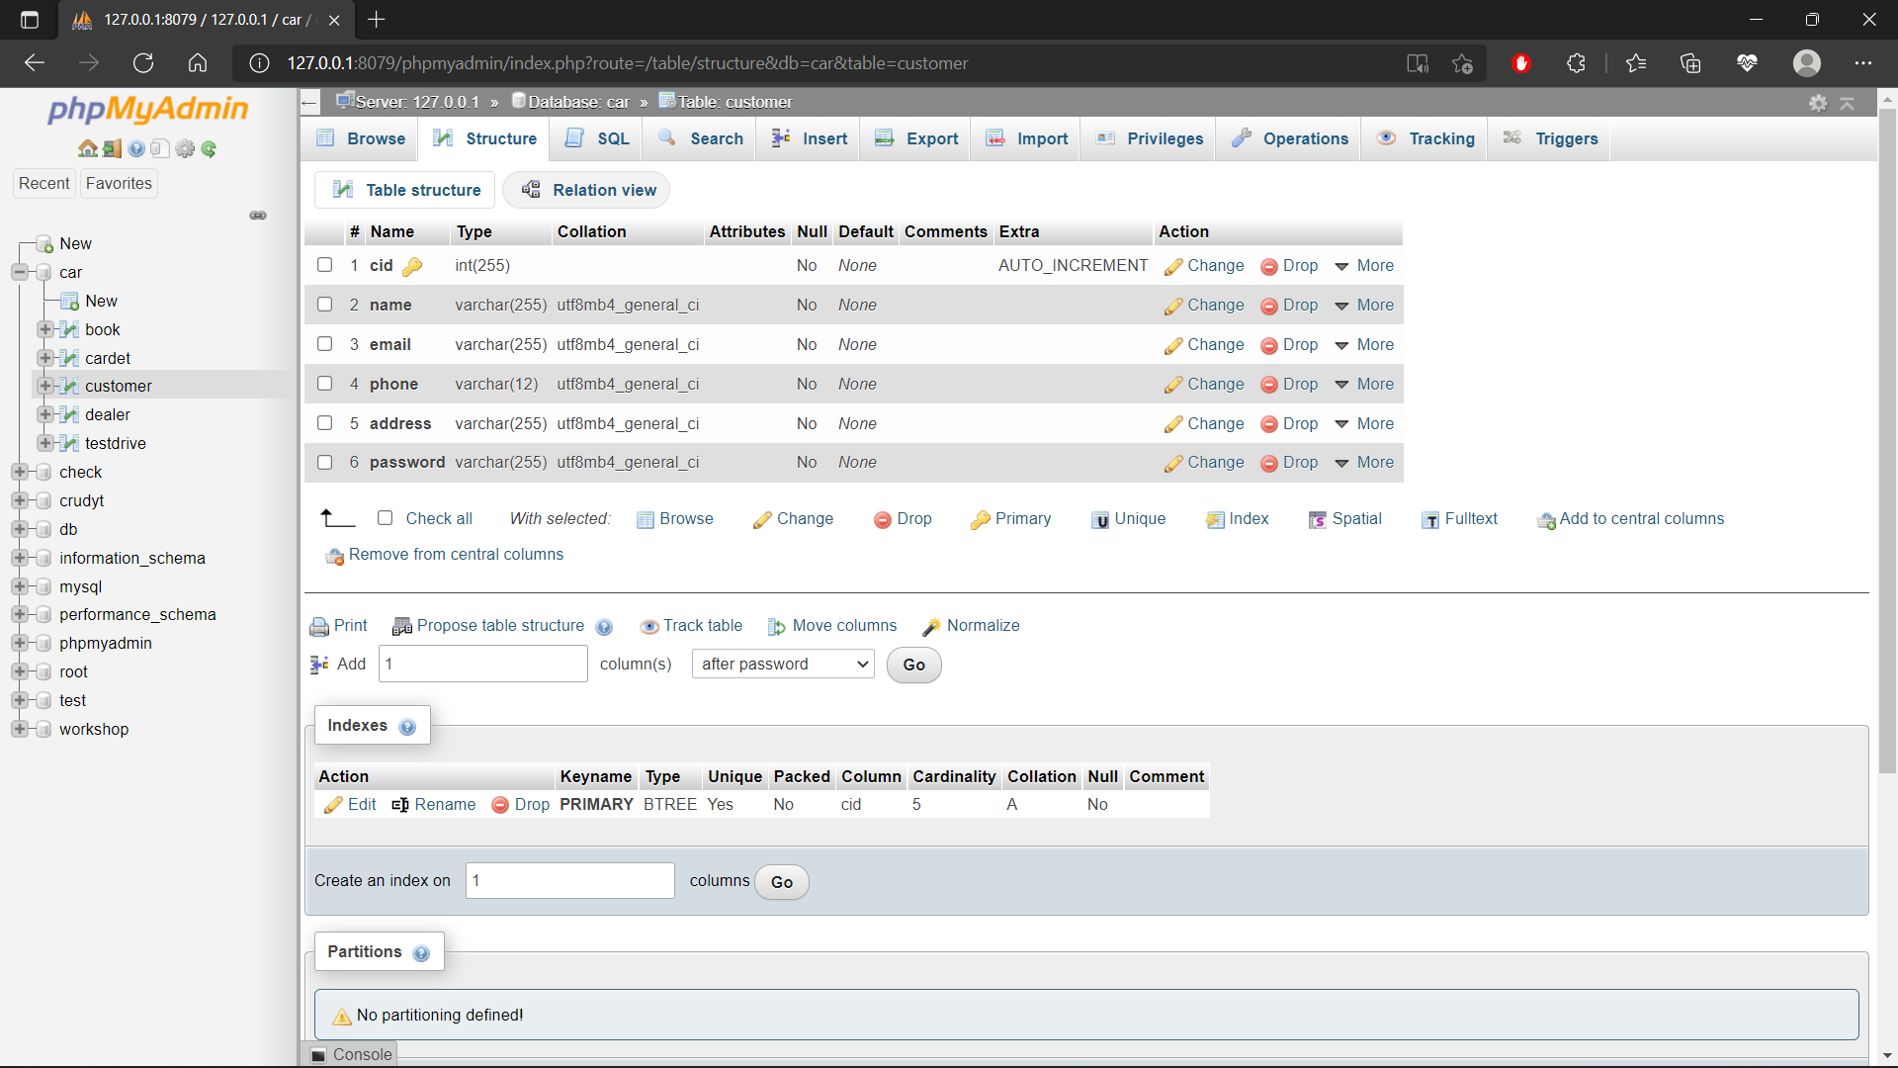

Table structures:

Customer:



Car:

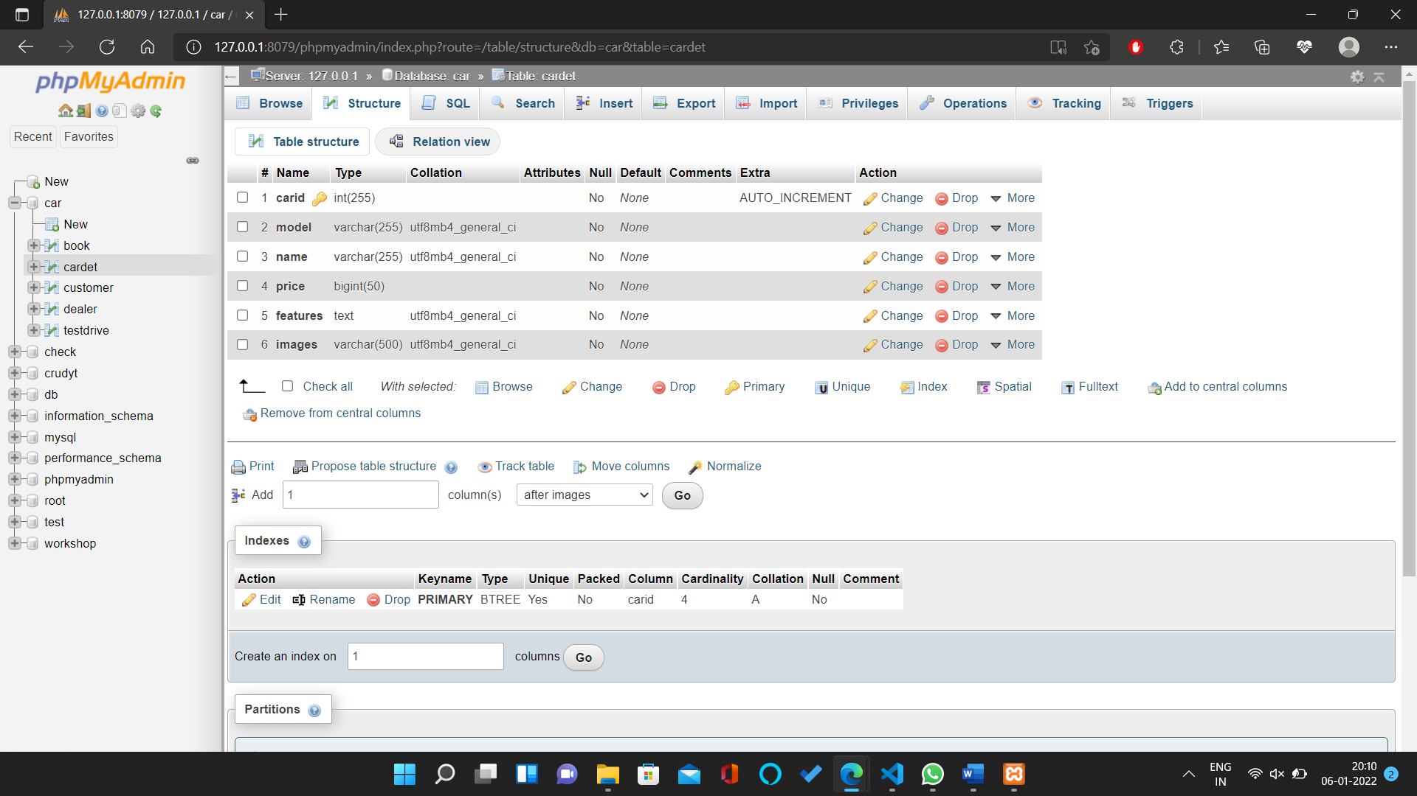

Book:

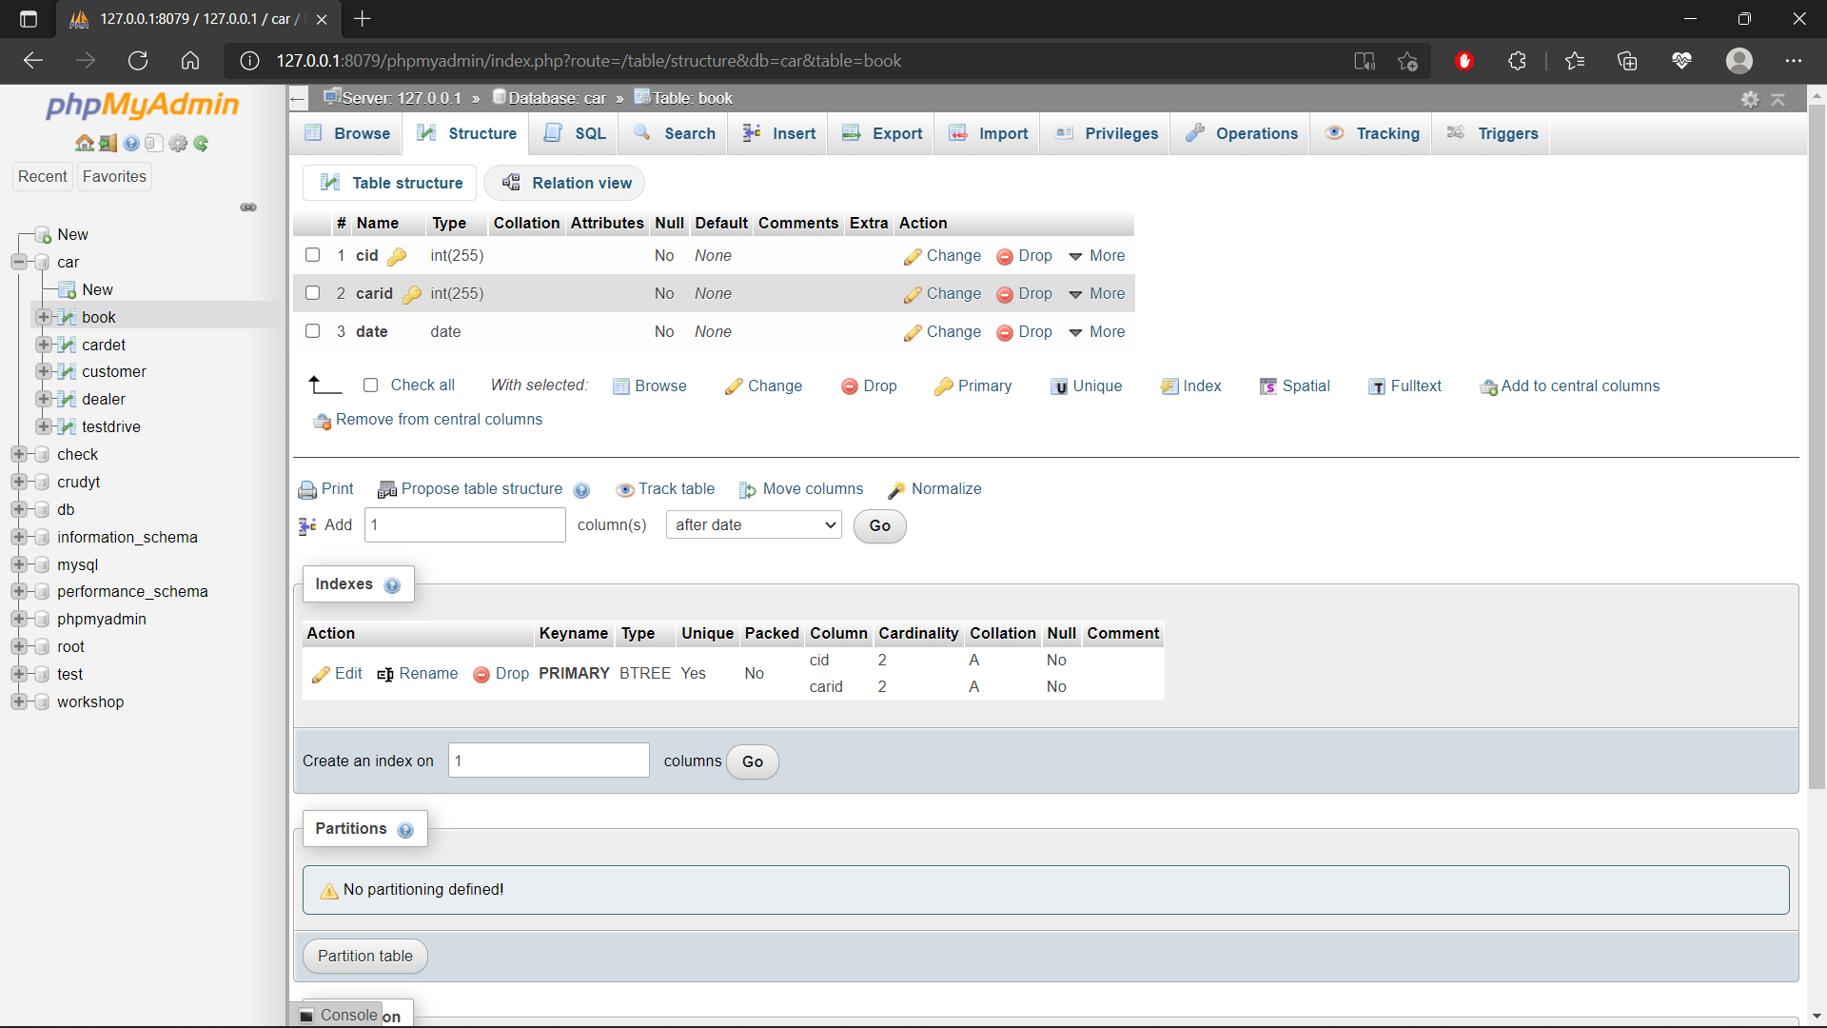

Webpage screenshot:

Homepage:

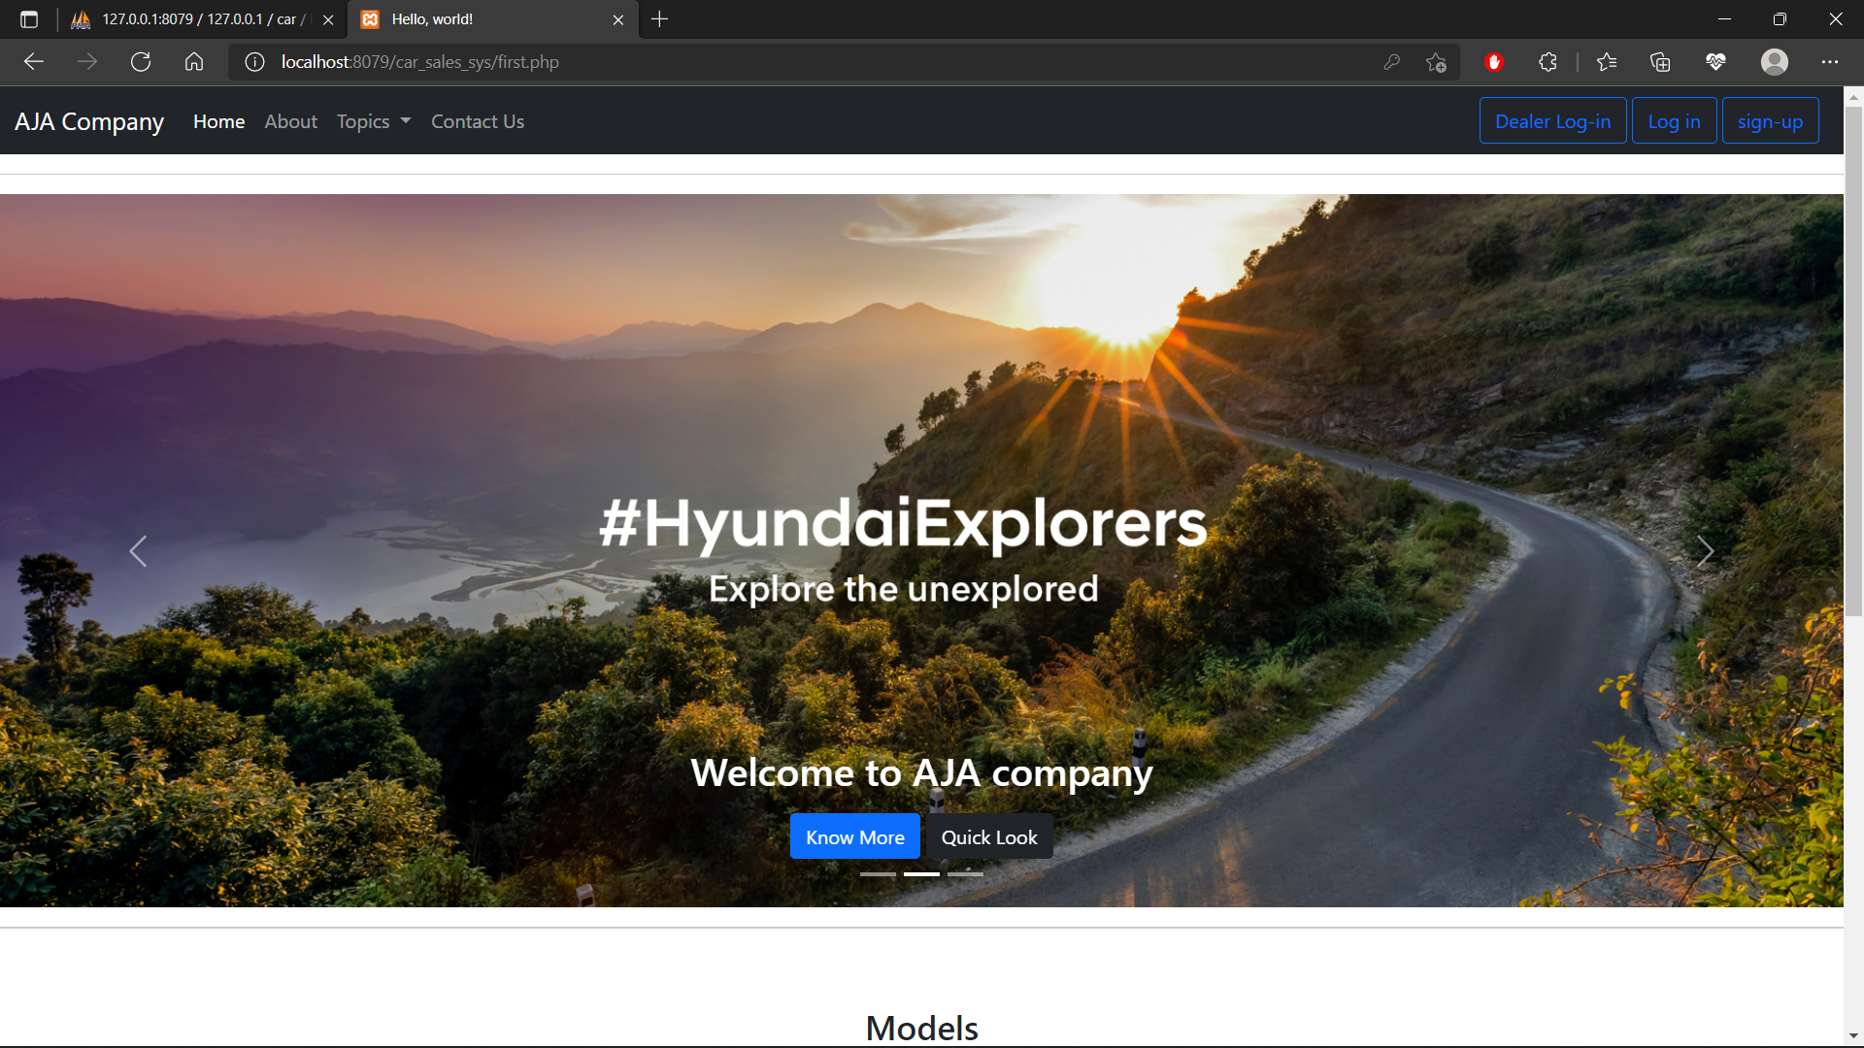

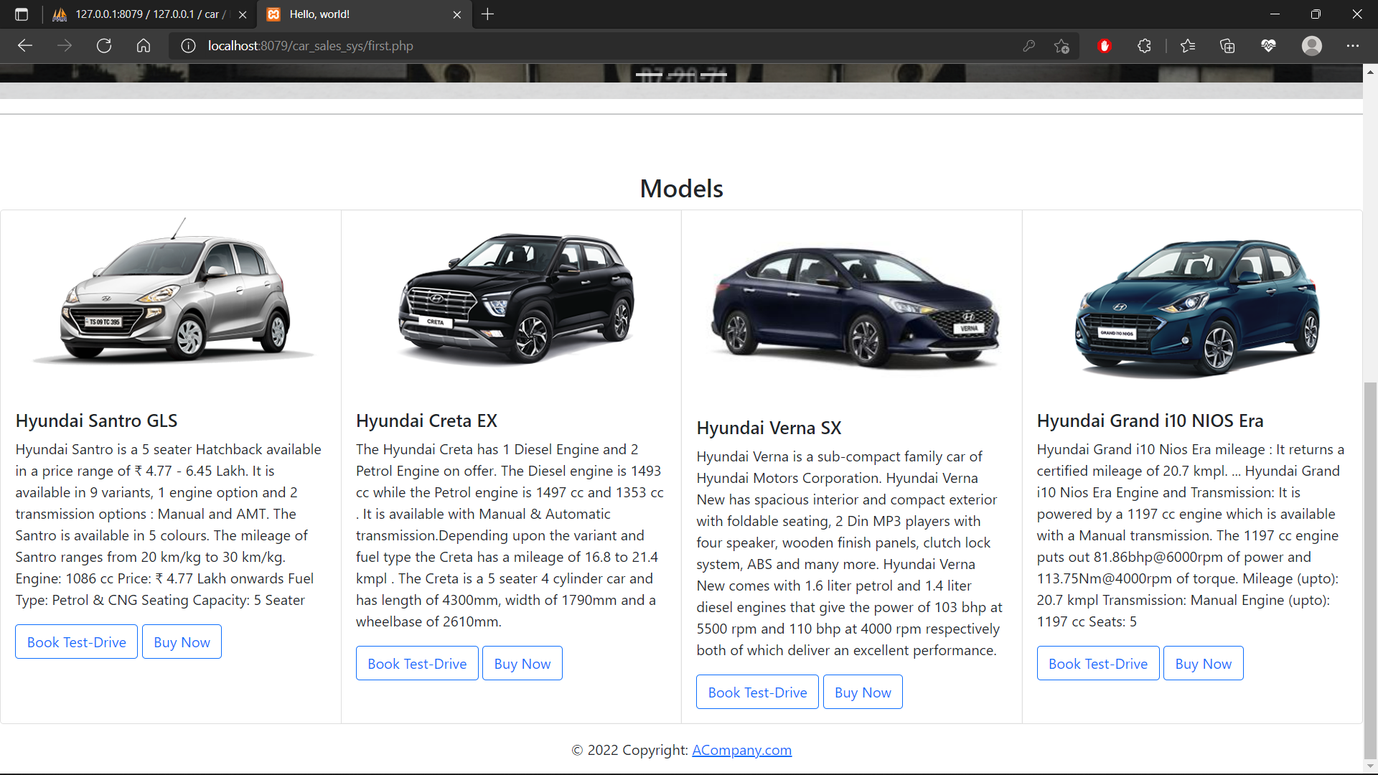

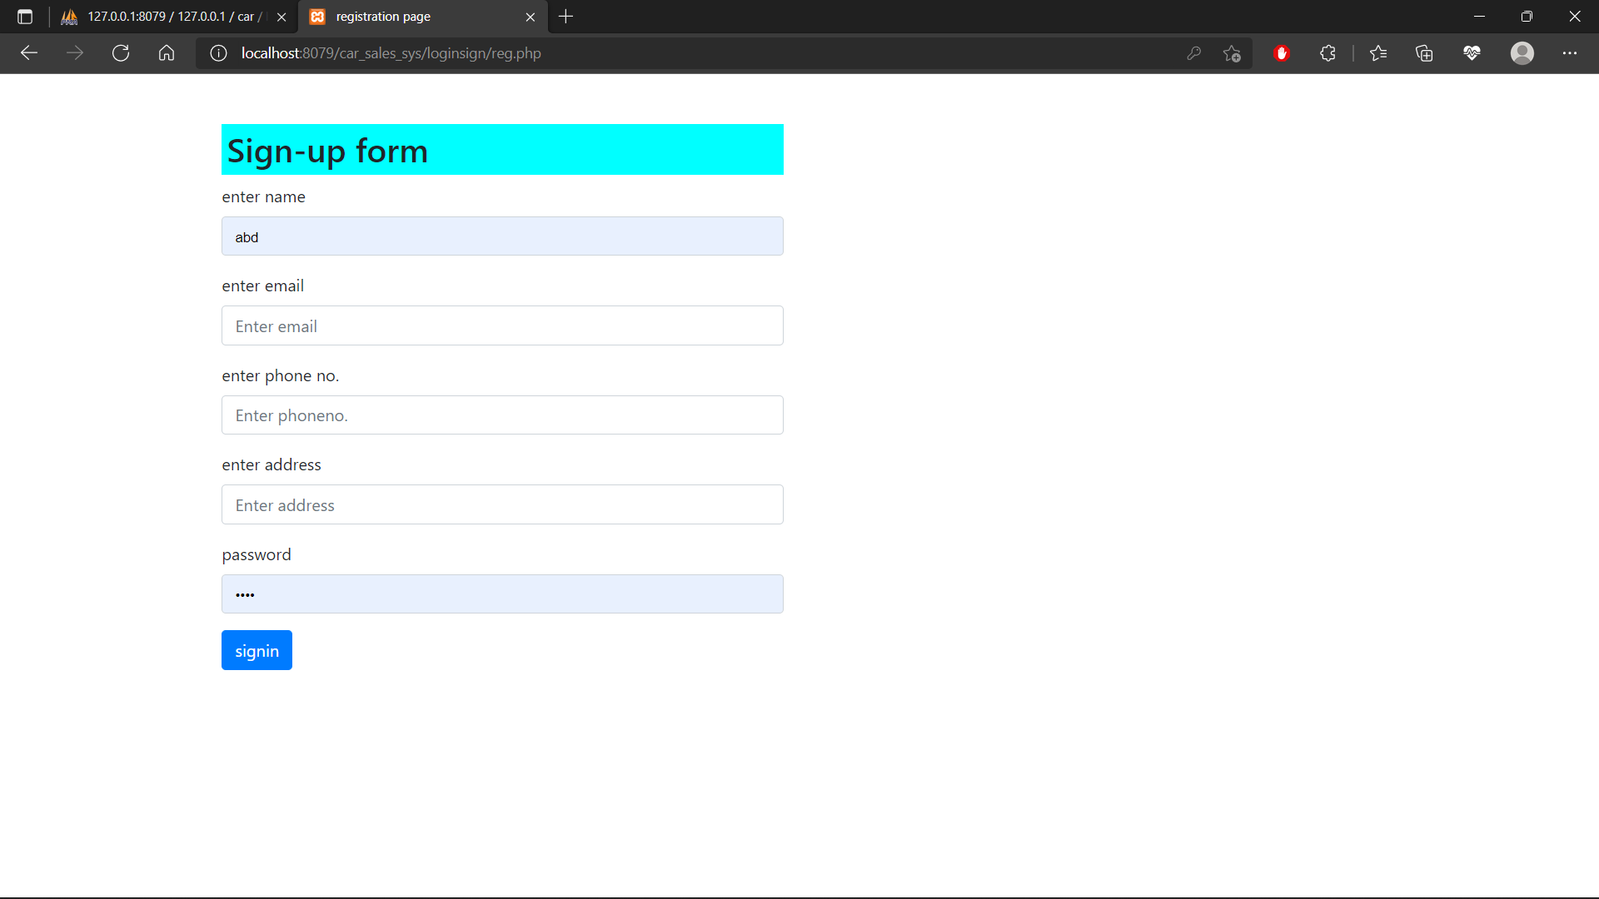

Admin Page:

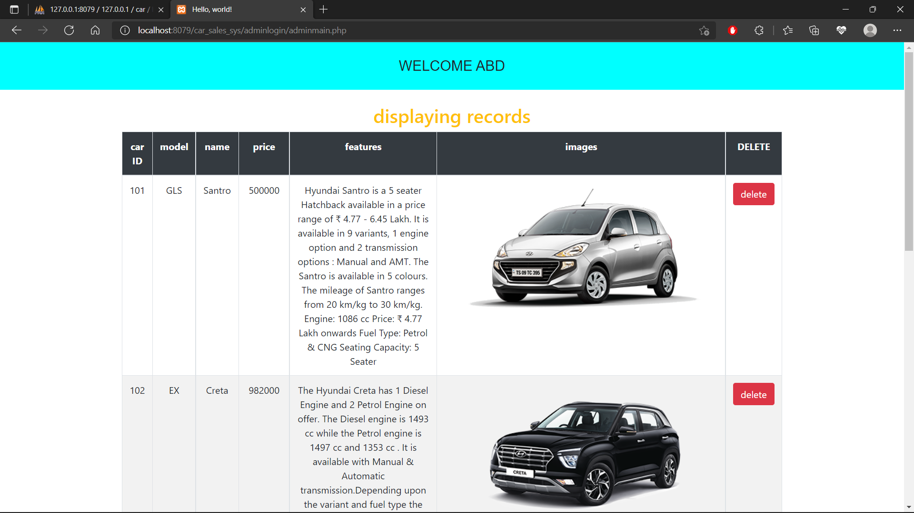

**7. Conclusion**

Project DOCUMENT for Car Sales System was successfully documented.